**Отчет по заданию Попрыженок**

**Николаев Вячеслав ИП 20-3**

**Диаграмма**

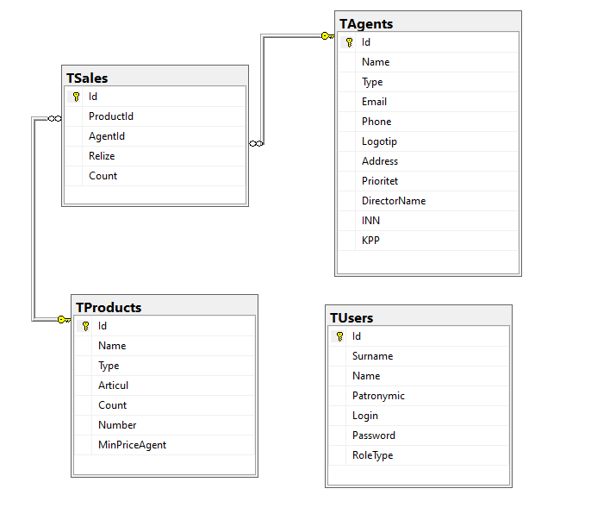

**Data Dictionary**

|  |  |  |  |  |
| --- | --- | --- | --- | --- |
| User  (Пользователи) |  |  |  |  |
| Key | Field Name | Data Type (Field Size) | Required? | Notes |
| PK | ID | INT | Y | Autoincrement |
|  | Surname | NVARCHAR (100) | Y | Фамилия |
|  | Name | NVARCHAR (100) | Y | Имя |
|  | Patronymic | NVARCHAR (100) | N | Отчество |
|  | Login | NVARCHAR (max) | Y | Логин |
|  | Password | NVARCHAR (max) | Y | Пароль |
|  | RoleType | INT | Y | Enum Type |

|  |  |  |  |  |
| --- | --- | --- | --- | --- |
| Product (Продукт) |  |  |  |  |
| Key | Field Name | Data Type (Field Size) | Required? | Notes |
| PK | Id | INT | Y | Autoincrement |
|  | Type | INT | Y | Enum Type |
|  | Name | NVARCHAR (300) | Y |  |
|  | Articul | NVARCHAR (300) | Y |  |
|  | Count | INT | Y |  |
|  | Number | INT | Y |  |
|  | MinPriceAgent | DECIMAL(18,2) | Y |  |

|  |  |  |  |  |
| --- | --- | --- | --- | --- |
| Agents (Агенты) |  |  |  |  |
| Key | Field Name | Data Type (Field Size) | Required? | Notes |
| PK | Id | INT | Y | Autoincrement |
|  | Type | INT | Y | Enum Type |
|  | Name | NVARCHAR (100) | Y |  |
|  | Logotip | NVARCHAR (MAX) | N |  |
|  | Address | NVARCHAR (MAX) | N |  |
|  | Prioritet | INT | Y |  |
|  | DirectorName | NVARCHAR (MAX) | N |  |
|  | INN | NVARCHAR (100) | Y |  |
|  | KPP | NVARCHAR (100) | Y |  |

|  |  |  |  |  |
| --- | --- | --- | --- | --- |
| Sales  (таблица Продажи) |  |  |  |  |
| Key | Field Name | Data Type (Field Size) | Required? | Notes |
| PK | Id | INT | Y | Autoincrement |
| FK | ProductId | INT | Y | Внешний ключ на Product |
| FK | AgentId | INT | Y | Внешний ключ на Agent |
|  | Relize | DateTimeOffset(7) | Y |  |
|  | Count | INT | Y |  |